Greetings from the AADB Leadership

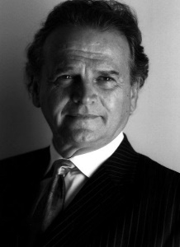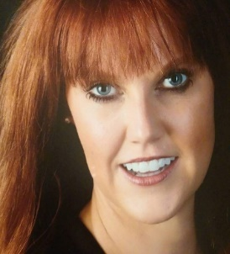

Distinguished Colleagues,

In light of recent developments, the AADB Board of Directors has decided the 2021 Mid-Year Meeting will be held virtually. Although we regret that we cannot meet face-to-face, a virtual meeting will provide a unique opportunity to share information safely and efficiently while leveraging technology to best serve our Members. After many thoughtful discussions, we believe this is the safest approach for the well-being of our global audience. More information will be published in the coming weeks. Of course, we have an exciting program planned!

The AADB Board of Directors would also like to congratulate RADM Timothy L. Ricks, DMD, MPH, FICD. He has been chosen as the recipient of the 2020 Special Recognition Award by the Dr. Edward B. Shils Entrepreneurial Fund for his leadership throughout the pandemic. His ability to build relationships among the public and private organizations has helped manage the crisis.

Finally, the letter to ADM Brett Giroir, MD, Assistant Secretary for Health at the U.S. Department of Health and Human Services has been sent. Ultimately 28 organizations signed the letter that is advocating for dental providers to be included in the COVID-19 vaccination strategy. Members can log-in to their Member’s Page to access the finalized letter.

We are looking forward to “seeing” you in February!

Best,
Robert Zena Tonia Socha-Mower
Robert Zena, D.M.D Tonia Socha-Mower, M.B.A, Ed.D. ( c )
AADB President AADB Executive Director

